Lab55
- Adding import blocks mapping each address to its real ID is essential to link the existing resources to their corresponding Terraform configuration. This step allows Terraform to recognize and manage the resources without recreating them.
-------------------------------------------
Which Terraform command checks modules, attribute names, and value types to ensure the configuration is syntactically valid and internally consistent?
Ans: The correct choice is terraform validate because this command is specifically designed to check and report errors within modules, attribute names, and value types to ensure they are syntactically valid and internally consistent.
The terraform validate command is used to check and report errors within modules, attribute names, and value types to ensure they are syntactically valid and internally consistent. This command performs basic validation of the Terraform configuration files in the current directory, checking for issues such as missing required attributes, invalid attribute values, and incorrect Terraform code structure.
For example, if you run terraform validate and there are syntax errors in your Terraform code, Terraform will display an error message indicating the line number and description of the issue. If no errors are found, the command will return with no output.
It's recommended to run terraform validate before running terraform apply to ensure that your Terraform code is valid and will not produce unexpected results.
Question 6:
Your organization manages a Google Cloud project with 50 resources across multiple services. You need to decommission only the Cloud SQL database instance and its backup policy while keeping all other infrastructure running. What is the most appropriate approach?
Correct answer
Remove the database and backup resource blocks from your configuration, then run terraform apply.
Explanation
By removing the database and backup resource blocks from your configuration and then running terraform apply, you specifically target only the resources you want to decommission while keeping the rest of the infrastructure intact. This approach ensures that only the Cloud SQL database instance and its backup policy are removed, meeting the requirement to decommission those resources while preserving the others.
The security team requires that you protect sensitive input values, such as API keys or passwords, in Terraform. Which methods follow Terraform guidance for reducing accidental exposure of secrets? (select two)
Provide secrets as short-lived, ephemeral values from an external system (for example, Vault) at runtime instead of hardcoding static credentials in version-controlled Terraform files.
Explanation
Providing secrets as short-lived, ephemeral values from an external system like Vault at runtime instead of hardcoding them in version-controlled Terraform files helps reduce the exposure of credentials. This approach follows Terraform best practices for securely managing sensitive information.
Correct selection
Mark variables as sensitive so Terraform redacts their values in CLI output and logs, limiting accidental disclosure of credentials during plan and apply.
Explanation
By marking variables as sensitive in Terraform, their values will be redacted in CLI output and logs, reducing the risk of accidental exposure of credentials during plan and apply operations. This aligns with Terraform's guidance on protecting sensitive input values.
Question 8:
When assigning a value to a Terraform input variable through an environment variable, which prefix string is necessary?
Correct answer
TF_VAR_
Explanation
The prefix string TF_VAR_ is necessary when assigning a value to a Terraform input variable through an environment variable. This prefix indicates that the environment variable is intended to set a Terraform variable.
What is the purpose of Terraform’s dependency graph?
builds a graph of dependencies to perform create/update/destroy operations from it
Explanation
Terraform's dependency graph is used to build a graph of dependencies between resources in the configuration. This graph is then used to determine the correct order of create, update, and destroy operations to ensure that resources are managed correctly.
Question 12:
Some of your production resources were created manually in the Azure portal. The company requires all production resources to be managed through Terraform. What should you do to bring those existing resources under Terraform management without disrupting them?
Your answer is correct
Use the import block to import the existing resources under Terraform management.
Explanation
Using the import block allows you to bring existing resources under Terraform management without disrupting them. This method enables you to map the existing resources to Terraform configuration and state files, ensuring that Terraform can manage them effectively without recreating or deleting them.
Question 13:
After creating several new Terraform configurations, you want to quickly format the files without editing each one manually. How can you update all the files at once?
terraform init
Explanation
The command terraform init is used to initialize a working directory containing Terraform configuration files. It prepares the directory for other Terraform commands but does not address the specific need to format all files at once. Therefore, it is not the correct choice for quickly updating all files simultaneously.
Your answer is correct
terraform fmt
Explanation
The command terraform fmt is used to automatically format all Terraform configuration files in the current directory. It helps maintain consistent formatting across all files without the need for manual editing, making it the ideal choice for quickly updating all files at once.
terraform refresh
Explanation
The command terraform refresh is used to reconcile the state Terraform knows about (via its state file) with the real-world infrastructure. It is not related to formatting Terraform configuration files and does not facilitate quick updates to all files at once, making it an incorrect choice for this scenario.
terraform validate
Explanation
The command terraform validate is used to check the syntax and validate the configuration files for any errors. While it is an important step in the Terraform workflow, it does not address the specific need to format all files simultaneously, making it an incorrect choice for updating all files quickly.
Overall explanation
Objective 3g - Apply formatting and style adjustments to a configuration
Terraform commands that generate Terraform configuration produce configuration files that conform to the style imposed by terraform fmt. Follow this style in your files to ensure consistency.
The canonical format may change in minor ways between Terraform versions, so after upgrading Terraform HashiCorp recommends to proactively run terraform fmt on your modules, along with any other changes you are making to adopt the new version.
What is the purpose of the Terraform state file?
C. Stores the mapping between resources and real infrastructure
Which command applies changes with auto-approval?
terraform apply -auto-approve

To see current resource values after running apply, use:
terraform show
terraform validate checks:
Syntax & internal consistency of Terraform configuration
When no backend is configured, Terraform stores state:
In a local file named terraform.tfstate
terraform graph is used to:
Visualize resource dependency graph
A map value always consists of:
Key-value pairs
This function merges two maps:
merge()
terraform console lets you:
Test expressions interactively- it will open a new console and we can check our expression which we defined
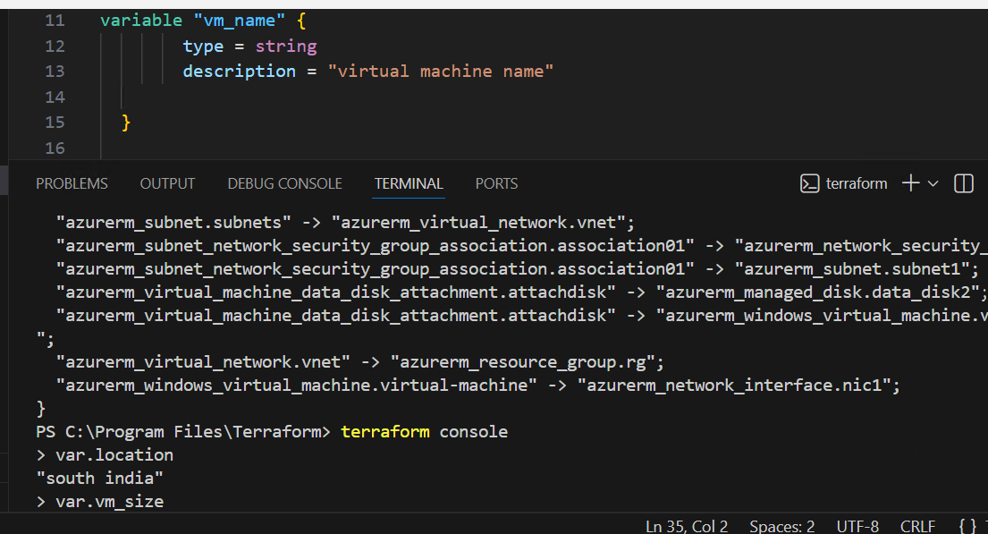
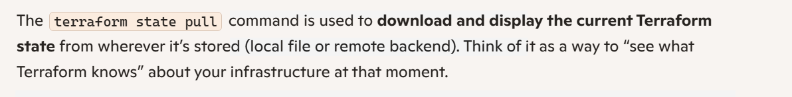
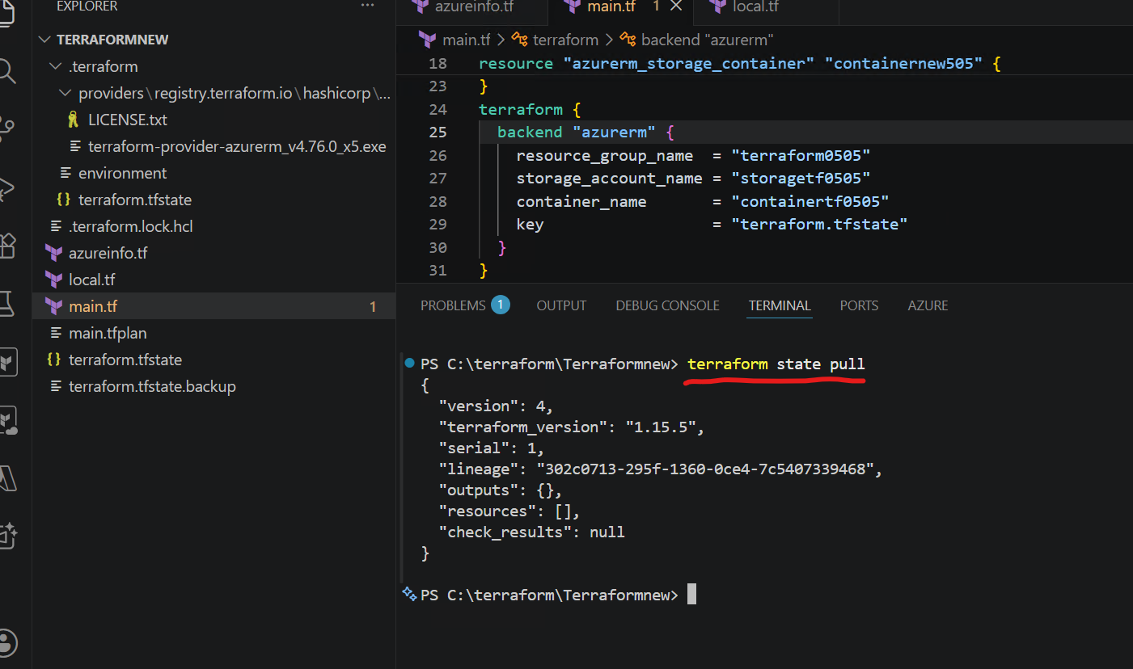
--------------------------------------------
To rename/move resources inside state:
terraform state mv
After manually updating infrastructure, Terraform detects changes by:
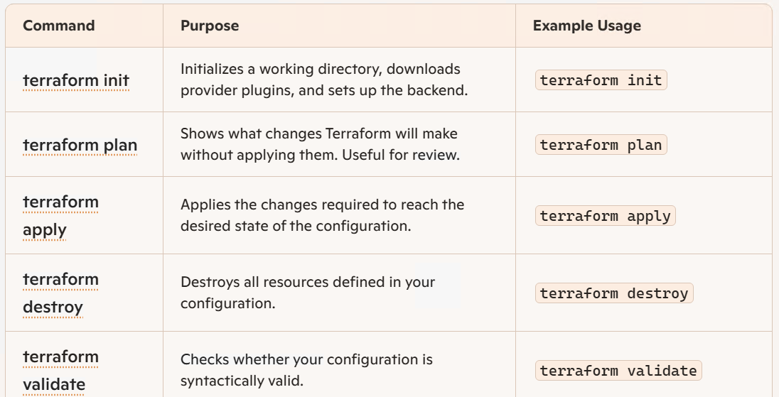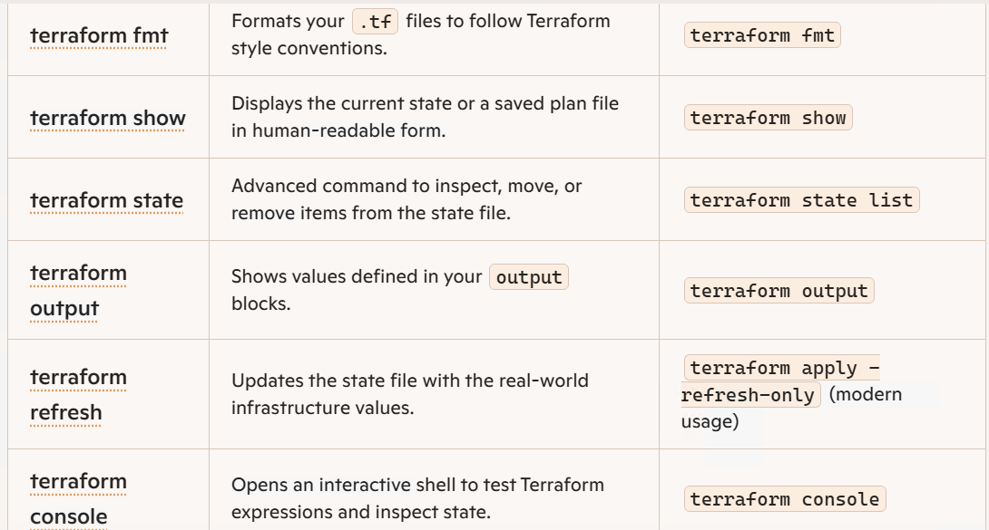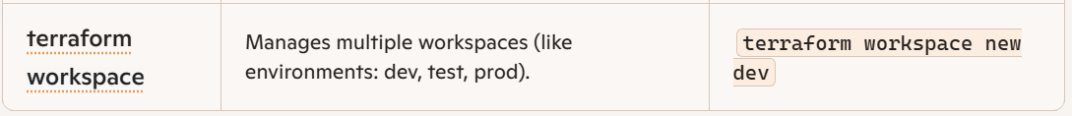
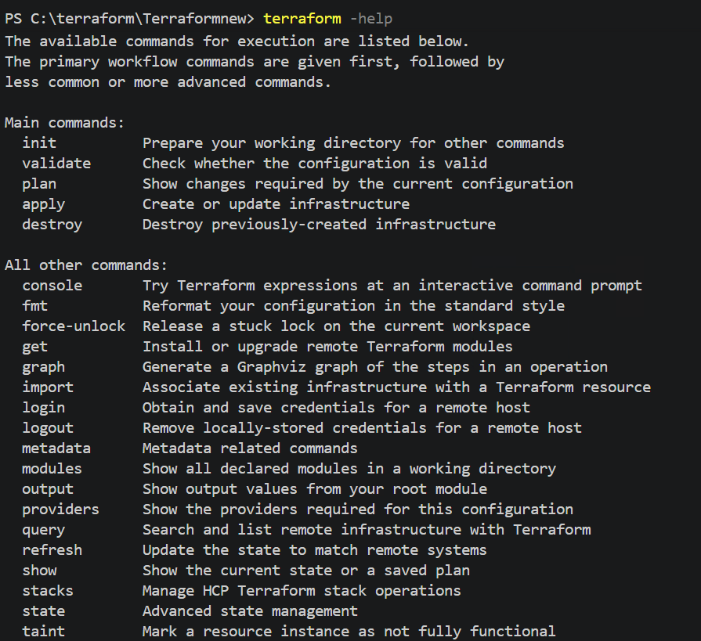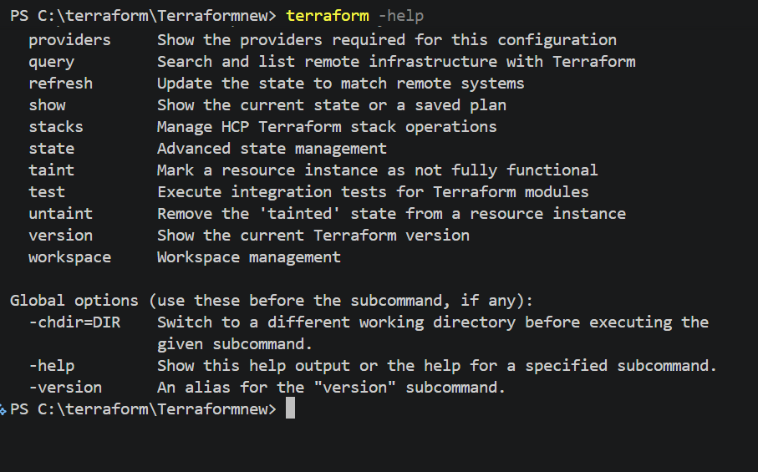
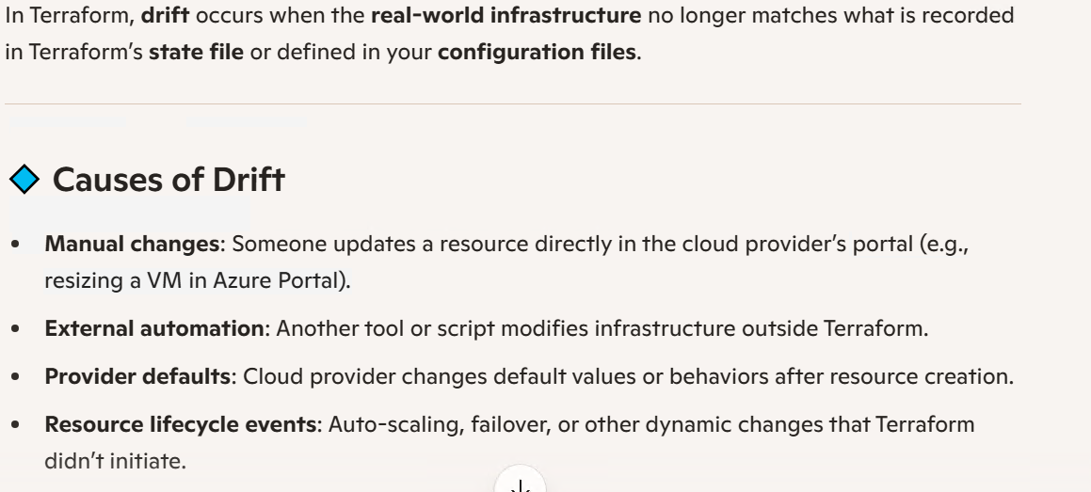
Real infrastructure has changed outside Terraform and no longer matches the desired state.
Explanation
"Drift" in the context of a workspace's state in Terraform refers to the scenario where the actual infrastructure has been modified outside of Terraform, causing it to deviate from the desired state defined in the configuration. This can lead to inconsistencies and potential issues in managing the infrastructure.
You run terraform init in a new working directory. The output shows Terraform downloading the aws and time provider plugins. On this machine, where does Terraform store those provider plugins?
The .terraform/providers directory in the current working directory
Explanation
The provider plugins downloaded by Terraform during the initialization process are stored in the .terraform/providers directory within the current working directory. This directory contains all the necessary provider plugins for the Terraform configuration to interact with the specified providers.
Why is using a single tool like Terraform for multi-cloud deployments more beneficial than using separate tools and workflows for each cloud?
It provides a common workflow and reusable modules, enabling consistent CI/CD and policy across clouds.
Explanation
Using a single tool, such as Terraform, for multi-cloud deployments enables a common workflow and reusable modules, simplifying infrastructure management and deployment. It also enables consistent CI/CD practices and policy enforcement across different cloud providers, leading to increased efficiency and standardization.
You have a Terraform project with multiple subdirectories: /dev, /staging, and /prod. Each directory contains a separate Terraform configuration for each different environment. Before deploying resources, where do you need to run terraform init?
In each directory (/dev, /staging, and /prod) since each is a separate working directory.
Explanation
Running terraform init in each directory is necessary because each directory contains a separate Terraform configuration for a different environment. This command initializes the working directory and prepares it for Terraform operations, ensuring that the necessary plugins and modules are available for that specific environment.
A resource was changed manually outside of Terraform. You don't want to make any changes yet, but you want to see how the state would be updated to match the current real-world values. Which command should you run?
Running terraform plan -refresh-only will show you how the state would be updated to match the current real-world values without making any changes to the infrastructure. This command will refresh the state of the resources without applying any changes.
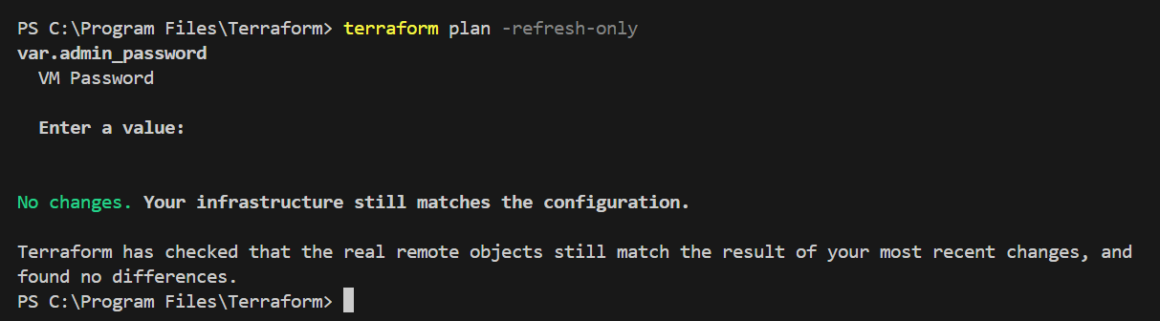
You've decided to change your backend configuration from S3 to HCP Terraform. After updating the backend block, you run terraform init. Which flag should you use to reconfigure the backend without copying the existing state?
terraform init -reconfigure
Explanation
Using the -reconfigure flag with the terraform init command allows you to reconfigure the backend without copying the existing state. This is the correct flag to use when changing the backend configuration without transferring the existing state data.
Aside from traditional code reviews, which Terraform command provides an opportunity for team members to review each other's work before deployment?
The terraform plan command generates an execution plan that describes what Terraform will do when you run terraform apply. This provides an opportunity for team members to review the proposed changes before deployment, allowing them to identify and address any potential issues or mistakes before they are applied to the infrastructure.
Why is state locking necessary when using a remote backend?
prevents concurrent runs from writing to the same state at the same time to avoid state corruption.
Explanation
State locking is necessary when using a remote backend to prevent concurrent runs from writing to the same state at the same time. This helps avoid conflicts and potential state corruption that can occur when multiple instances of Terraform try to modify the state simultaneously.
Your team uses HCP Terraform with a CLI-driven workflow. After making changes to your configuration locally, you run terraform plan. Where does the plan operation execute?
on HCP Terraform infrastructure with results streamed back to your terminal
Explanation
When you run the terraform plan command in a CLI-driven workflow with HCP Terraform, the plan operation is executed on the HCP Terraform infrastructure. The results of the plan are then streamed back to your terminal for review and analysis, allowing you to see the planned changes and potential impacts directly from the HCP Terraform environment.
Including the version argument in a Terraform module block allows you to specify a specific version of the module to use. This helps to ensure that the module does not unexpectedly upgrade to a newer version, which could potentially introduce breaking changes or compatibility issues with the existing infrastructure.

What is terraform.tfstate (Azure Perspective)
From Azure’s point of view, terraform.tfstate is Terraform’s internal database that tracks all Azure resources created or managed by Terraform.
Azure itself does not store or maintain this file—Terraform does.
But for Azure, this file is extremely important because it tells Terraform:
- which Azure resources exist
- their Azure Resource IDs
- their actual configuration in Azure
- the dependencies between Azure resources
This allows Terraform to manage your Azure infrastructure correctly.
🔍 1. Maps Terraform Resources to Real Azure Resources
When you create an Azure resource (VM, VNet, RG, NSG, etc.) using Terraform, Terraform stores Azure’s actual resource ID and metadata inside terraform.tfstate.
Example Azure ID stored inside the state:
/subscriptions/<sub-id>/resourceGroups/rg-app/providers/Microsoft.Network/virtualNetworks/vnet-app
Without this mapping, Terraform would not know:
- which Azure resources it owns
- which ones it should update
- which ones it should delete
🔄 2. Allows Terraform to Detect Changes in Azure
When you run:
Shell
terraform plan
Show more lines
Terraform compares:
- Your .tf configuration
- The real Azure environment (via ARM API)
- The terraform.tfstate file
This is how Terraform decides what must be:
- created
- modified
- destroyed
The state file is the bridge between Terraform and Azure’s live infrastructure.
🔗 3. Tracks Dependencies Between Azure Resources
Azure resources often depend on each other, for example:
- A VM → NIC → Subnet → VNet
- App Service → App Service Plan
- Key Vault → Access Policies
- AKS → Managed Identities → VNet
Terraform stores these relationships inside the state file, so it knows:
- creation order
- deletion order
- what must be recreated vs updated
🔐 4. Stores Azure Resource Attributes & Secrets
Azure returns many values that you do not explicitly define in .tf files, such as:
- Storage account keys
- SAS tokens
- Private IPs
- Endpoint URLs
- Principal IDs (Managed Identity)
In Terraform, the lifecycle meta-argument is used to manage the lifecycle of a resource. It provides a way to specify additional behavior that affects how Terraform handles changes to a resource. Examples of these sub-arguments include create_before_destroy, prevent_destroy, ignore_changes, and depends_on.
The lifecycle meta-argument supports several sub-arguments, including:
- create_before_destroy: This boolean value determines whether Terraform creates a new resource before destroying the old one. If set to true, Terraform will create a new resource before destroying the old one. This is useful for resources that can’t be updated in place, such as databases.
- prevent_destroy: This boolean value determines whether Terraform can destroy a resource. If set to true, Terraform will prevent the resource from being destroyed. This is useful for resources that should never be deleted, such as production databases or key management systems.
- ignore_changes: This list of attributes determines which resource attributes Terraform should ignore when determining whether a change has occurred. If an attribute is listed here, Terraform will ignore changes to that attribute and not try to update it.
Terraform lifecycle Meta-Argument Explained | by Sumit K | Medium
lifecycle meta-argument reference | Terraform | HashiCorp Developer
Understanding the default behavior of the Terraform resource lifecycle can help avoid unwanted downtime when Terraform executes operations. The lifecycle of every resource can be manipulated as needed using the lifecycle meta-argument.
Terraform Resource Lifecycle Meta-Argument [Examples]
for_each in Terraform creates multiple instances of a resource or module using a given collection (list, map, or set) without having to manually define each one. From an Azure perspective, this construct is essential for provisioning multiple Azure resources using less repetitive code.
Here is a breakdown of how for_each, each.key, and each.value work, illustrated with Azure examples.
for_each
The for_each argument accepts a map or a set of strings. Terraform uses the elements in the collection to create instances of a resource, with one instance for each item.
Azure Example: Creating Multiple Resource Groups
Instead of writing a separate azurerm_resource_group block for every group, you can define your desired groups in a single variable:
hcl
variable "resource_groups" {
description = "A map of resource groups to create (name: location)"
type = map(string)
default = {
"rg-networking-eastus" = "East US",
"rg-compute-westus" = "West US",
"rg-database-centralus" = "Central US"
}
}

resource "azurerm_resource_group" "example" {
for_each = var.resource_groups

# ... other attributes using each.key and each.value
}
each.key and each.value
Inside a resource or module block that uses for_each, you can access metadata about the current iteration using the special each object.
Attribute | Description
each.key | The key of the current element in the map, or the value of the current element in a set.
each.value | The value of the current element in the map, or undefined when using a set.
Azure Example: Using each.key and each.value
Continuing the previous example, we use each.key to name the resource group and each.value for the location:
hcl
resource "azurerm_resource_group" "example" {
for_each = var.resource_groups

# each.key will be "rg-networking-eastus", "rg-compute-westus", etc.
name = each.key

# each.value will be "East US", "West US", etc.
location = each.value
}

A Terraform data source is a read-only construct that allows querying provider APIs to retrieve specific attributes or information that can be used in other parts of the configuration. It helps in integrating external data into Terraform configurations without actually creating or managing any infrastructure resources.
Data sources enable fetching or computing data for use elsewhere in a Terraform configuration. The use of data sources enables a Terraform configuration to leverage information defined outside of Terraform or by another separate Terraform configuration.
terraform show is a command that displays the entire state file, including all resources and their current configuration, without the need for any additional arguments. It provides a high-level overview of the managed infrastructure.
terraform show is particularly useful when you want to have a comprehensive overview of all the managed infrastructure in your Terraform configuration. It allows you to see the current state of all resources at once.
When using terraform state show, you need to specify a resource address to view the details of that specific resource. This command allows you to inspect the state of individual resources within the Terraform state.
Aspect | terraform show | terraform state show
Scope | Entire state or plan file | Single object by address
Format | Human-readable or -json | Human-readable only
Input | Current state (default) or a .plan file | Always the current state
Use case | Overview, auditing, exporting to tools | Deep-dive into one resource/data
Filtering | No (it’s everything) | Yes (one address)

The .terraform directory stores Terraform’s local working data, including installed provider and module plugins, backend metadata, and state lock information.
The .terraform directory is used to store Terraform's local working data, such as installed provider and module plugins, backend metadata, and state lock information. This directory helps Terraform manage and track the necessary components for executing infrastructure changes.
HCP Terraform (formerly Terraform Cloud) is HashiCorp’s SaaS platform that helps teams run Terraform securely, collaboratively, and at scale. It adds features on top of the CLI to solve real-world challenges like state management, access control, drift detection, and policy enforcement.
According to HashiCorp, HCP Terraform manages Terraform runs in a consistent hosted environment, provides shared remote state, integrates with VCS, and offers collaboration & governance features. [developer....hicorp.com]
It is designed for teams that want automation, security, and centralized management when using Terraform.
You have configured a workspace in HCP Terraform to use local execution. In this mode, what does HCP Terraform do?
When using local execution in HCP Terraform, the platform only handles storing and syncing the workspace's state file. This means that you need to run the plan and apply commands locally on your own machine, while HCP Terraform takes care of managing the state file.
Your team's change management process requires that all Terraform changes be reviewed and approved before execution. You run terraform plan -out=bk-project.tfplan and send the output for review. After approval is granted two hours later, what command should you run to execute the exact changes that were reviewed?
Ans:
Running terraform apply bk-project.tfplan will execute the exact changes that were reviewed and approved in the saved plan file. This ensures that only approved changes are applied to the infrastructure, in accordance with the change management process requirements.
You're using a module from the Terraform registry for your infrastructure. When defining the configuration, is it necessary to specify a version argument in the module block?

The version argument in the module block is optional, but it is highly recommended to specify a version to ensure consistent and reproducible deployments. Without a version specified, Terraform defaults to the latest version of the module, which may lead to unexpected changes in your infrastructure.
While the version argument is not strictly required for registry modules, omitting it means Terraform will select the latest available version during terraform init. This can lead to unexpected changes if a new module version introduces breaking changes or modified behavior. Best practice is to always specify a version constraint (like version = "~> 2.1.0") to ensure your infrastructure deployments are consistent and reproducible across different team members and environments. The version is then recorded in the dependency lock file for additional consistency.
Terraform relies on plugins called "providers" to interact with remote systems. Terraform configurations must declare which providers they require, so that Terraform can install and use them.
You are using a local backend and accidentally delete the terraform.tfstate file for your workspace. What is the most serious consequence?
If the terraform.tfstate file is deleted, Terraform loses track of the current state of the managed resources. This can lead to potential conflicts and inconsistencies when running the next plan or apply commands, as Terraform may attempt to recreate resources that already exist or fail to manage resources that have been modified outside of Terraform.
ccidentally delete the terraform.tfstate file, the most serious consequence is:
❗ Terraform permanently loses knowledge of all managed infrastructure
Because with a local backend, the terraform.tfstate file is the only place Terraform stores:
- resource IDs
- dependencies
- metadata
- outputs
- the entire mapping of real cloud resources to your Terraform configuration
Deleting it means Terraform no longer knows what it previously created.
There is no remote backup, no state history, and no automatic recovery.
The Terraform state is stored in the file terraform.tfstate.
terraform.lock.hcl is Terraform’s dependency lock file. It records the exact provider versions (and their checksums) that were selected the last time you ran terraform init, so that every teammate and CI runner resolves the same provider builds on future runs—ensuring repeatable, deterministic plans/applies across machines and over time.
terraform.lock.hcl is Terraform’s dependency lock file. It pins exact provider builds (name, version, and checksums per OS/arch) that were selected during the last terraform init, ensuring deterministic, reproducible runs across developers, machines, and CI systems.

In HCP Terraform, a run trigger is used to automatically start a run in one workspace when another workspace successfully completes an apply.
Here’s the purpose in simple, clear terms:

🎯 Purpose of a Run Trigger in HCP Terraform
A run trigger connects two workspaces so that:
When the source workspace finishes an apply successfully, the dependent (target) workspace automatically queues a new run.
This is used when one workspace depends on outputs or infrastructure created by another.
It ensures downstream infrastructure stays in sync.
✔ Based on official HashiCorp documentation, run triggers
- connect your workspace to “source workspaces”,
- and automatically queue runs after successful applies in those source workspaces. [developer....hicorp.com]
✔ They are designed specifically for workspaces that rely on info or infrastructure produced by other workspaces.
If a configuration uses data sources that depend on these values, run triggers explicitly define that dependency. [developer....hicorp.com]
✔ They establish a dependency chain between workspaces — ensuring downstream runs execute whenever upstream changes apply. [trustedinstitute.com]
In HCP Terraform, a run trigger is used to automatically start a run in one workspace when another workspace successfully completes an apply.
Here’s the purpose in simple, clear terms:

🎯 Purpose of a Run Trigger in HCP Terraform
A run trigger connects two workspaces so that:
When the source workspace finishes an apply successfully, the dependent (target) workspace automatically queues a new run.
This is used when one workspace depends on outputs or infrastructure created by another.
It ensures downstream infrastructure stays in sync.
✔ Based on official HashiCorp documentation, run triggers
- connect your workspace to “source workspaces”,
- and automatically queue runs after successful applies in those source workspaces. [developer....hicorp.com]
✔ They are designed specifically for workspaces that rely on info or infrastructure produced by other workspaces.
If a configuration uses data sources that depend on these values, run triggers explicitly define that dependency. [developer....hicorp.com]
✔ They establish a dependency chain between workspaces — ensuring downstream runs execute whenever upstream changes apply. [trustedinstitute.com]
Run triggers connect workspaces so that when a “source” workspace completes a successful apply, HCP Terraform automatically queues a run in the “downstream” workspace. This is commonly used to keep dependent stacks in sync.
Why should users not commit the terraform.tfstate file to version control? (select two)
Committing the terraform.tfstate file to version control can expose plaintext secrets and detailed resource data, as well as the commit history. This can pose a security risk by making sensitive information accessible to unauthorized users.
Version control systems (VCS) do not provide state locking, which means that concurrent runs of Terraform can lead to conflicting commits and potentially corrupt the state file. This can result in inconsistencies and errors in the infrastructure management process.
You have a variable containing subnet CIDR blocks as a list: ["10.0.5.0/24", "10.0.0.0/24", "10.0.2.0/24"]. You need to determine how many subnets are in the list to use. Which function returns the number of elements?
The length() function in Terraform is used to return the number of elements in a list. In this case, length(var.subnet_cidrs) will return the number of subnet CIDR blocks in the list, which is what is required to determine how many subnets are in the list.
The keys() function in Terraform is used to return a list of keys in a map variable,
The contains() function in Terraform is used to check if a value exists in a list or map.
The values() function in Terraform is used to return a list of values in a map variable,
Terraform isn’t a “mutable language” or “immutable language.”
It is a declarative IaC tool that supports immutable patterns where appropriate.

🧩 Simple Summary
- Mutable → Terraform updates the resource directly
- Immutable → Terraform destroys & recreates the resource
- Terraform uses both, depending on the provider’s resource rules (ForceNew)
- Terraform is indeed an immutable and declarative Infrastructure as Code provisioning language. It allows users to define the desired state of their infrastructure and Terraform will make the necessary changes to reach that state. The language is based on HashiCorp Configuration Language (HCL) or JSON for configuration files.

Terraform’s state is the source of truth that maps configuration to real infrastructure, so it often contains actual values used during provisioning, including credentials, connection strings, and rendered templates. By default, these values are stored in plaintext in the state file (local or remote). Marking variables or outputs as sensitive = true only redacts them from CLI/UI output; it does not keep the values out of state.
Therefore, protecting secrets means protecting state: prefer remote backends with encryption at rest, IAM/RBAC, and state locking; restrict who can read state; avoid surfacing secrets in outputs; and minimize where secrets appear in configuration. In short, assume state may contain secrets and treat it as sensitive data that must be encrypted, access-controlled, and audited.
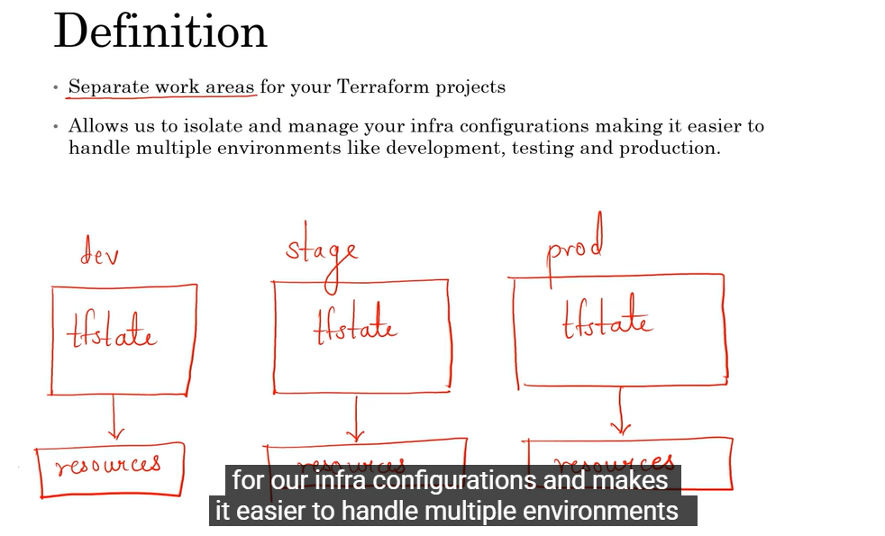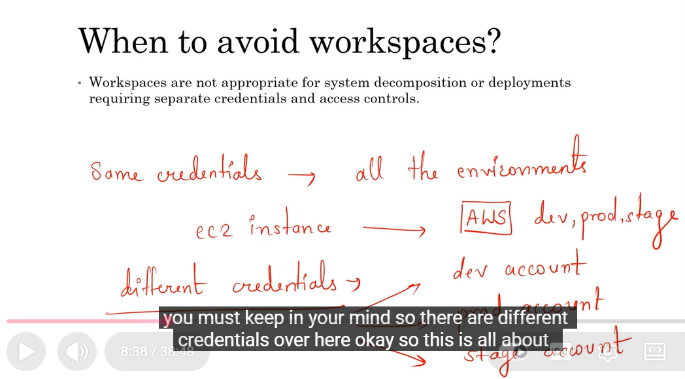

Q. Your team manages infrastructure across multiple AWS regions using Terraform. You want to see a complete list of all resources currently tracked in your Terraform state file, but don't need the detailed attributes of each resource. Which command should you use?
Ans: The terraform state show command is used to show the attributes of a specific resource in the Terraform state.
The terraform show command is used to display the current state or configuration of Terraform-managed infrastructure. It provides detailed information about resources, their attributes, and their dependencies, but it does not list all resources concisely.
The terraform state list command is used to quickly list all resources currently tracked in the Terraform state file without displaying the detailed attributes of each resource. This command provides a high-level overview of the resources being managed by Terraform.
In HCP Terraform, a workspace can be mapped to only one VCS (Version Control System) repository. This means that the workspace will be associated with a single repository where the Terraform configuration files are stored and managed.
The terraform fmt -diff command is used to show the differences between the current formatting of Terraform files and the formatted version.
The terraform fmt -check command is used to check whether Terraform files are properly formatted without making any changes. It validates file formatting and ensures consistency across all files in the repository before merging into the main branch.
The terraform fmt -check flag is specifically designed for CI/CD pipelines and pre-commit hooks. It checks whether files are properly formatted according to Terraform style conventions without changing the files. If formatting issues are found, the command exits with a non-zero status code, which can cause the pipeline to fail and alert developers to run terraform fmt before committing. This is the standard approach for enforcing code formatting standards in automated workflows.
In Terraform, a data block (also called a data source) is used to read or fetch information defined outside of the current Terraform configuration, such as:
- Existing cloud resources
- Information from providers (e.g., AMI IDs, VPC details)
- External services
- Other Terraform states
It does NOT create anything. Instead, it retrieves data that you can reference in your resource configurations.
use a data block to reference the existing VNet, then create your VM resources that use attributes from the data source
Sentinel policies in Terraform — a quick, practical overview
What is Sentinel?
Sentinel is HashiCorp’s policy-as-code framework. In the Terraform world, it lets you write rules (in a simple policy language) that automatically check Terraform runs—plan, apply, and destroy—so your infrastructure changes follow your organization’s standards (security, compliance, cost, tagging, regions, etc.).
Sentinel enforcement runs in Terraform Cloud/Enterprise (not in the open-source CLI by itself).

Where Sentinel fits in the Terraform workflow
- Developer opens a PR → terraform plan runs in Terraform Cloud/Enterprise.
- Sentinel evaluates your policies against the run’s data (the plan, configuration, state, and run metadata).
- The run is allowed or blocked based on policy decisions.

Core concepts
- Policy: A small program written in the Sentinel language that returns true (pass) or false (fail).
- Enforcement level:
  - advisory: Violations are recorded, but the run can proceed.
  - soft-mandatory: Violations can be overridden by an authorized user.
  - hard-mandatory: Violations block the run—no overrides.
- Policy set: A collection of policies attached to one or more workspaces (e.g., “all-prod workspaces”).
- Imports: Data sources the policy can read:
  - tfplan – proposed changes (resources to add/change/destroy, arguments).
  - tfconfig – raw Terraform configuration.
  - tfstate – current state.
  - tfrun – run metadata (workspace, user, VCS info).

Restrict costly SKUs (e.g., VM sizes only from an allowlist)
# policies/restrict-skus.sentinel
import "tfplan/v2" as tfplan
allowed_sizes = ["Standard_B2s", "Standard_B4ms", "Standard_D2s_v5"]

You write Sentinel policies (policy-as-code) that evaluate Terraform runs (plan/config/state) in TFC/E and block or allow changes based on your rules—e.g., “storage accounts must enforce HTTPS,” “NSGs must not allow 0.0.0.0/0 on 22/3389,” “tags are required,” etc.
What Is Secrets Management in Terraform (Azure)?
Secrets Management in Terraform Azure refers to the secure handling of sensitive values—such as:
- Azure client secrets
- Service principal passwords
- Storage account keys
- Database passwords
- API keys
- Certificates, connection strings, etc.
Terraform itself does not create a secrets vault.
Instead, Terraform integrates with Azure Key Vault (or other vaults) so that secrets are:
✔️ Stored securely outside Terraform code
✔️ Not hardcoded in .tf files
✔️ Not committed to GitHub
✔️ Not displayed in Terraform logs or state (if handled correctly)

⭐ Why is Secrets Management important?
Because Terraform state files can contain sensitive data, and code can be leaked in Git.
Good secrets management ensures:
- No passwords in plaintext
- No secrets in Git repos
- No exposure through Terraform state
- Compliance & governance (SOC2, ISO, PCI, etc.)
- Secure rotation and centralized auditing

🔐 Key Concepts in Terraform Azure Secrets Management
1️⃣ Store secrets in Azure Key Vault (AKV)
This is the Azure-native secure storage solution.
Best Practices (You Should Always Follow)
✔ Don’t store secrets in:
- Terraform .tf files
- Variables without sensitive = true
- GitHub actions YAML
- Terraform state
✔ Do store secrets in:
- Azure Key Vault (recommended)
- Terraform Cloud workspace variables (sensitive = true)
- Azure DevOps variable groups (secret = true)
✔ Use Managed Identity instead of SP client secrets
Where possible, avoid passwords completely.
✔ Rotate secrets using:
- Key Vault automatic rotation
- Random providers (random_password)

🧩 Summary
Concept | Meaning
Secrets management | Secure handling of sensitive values
Azure Key Vault | Recommended place to store and retrieve secrets
Sensitive variables | Prevent secrets from showing in logs
Secure backend | Prevents secrets leakage via state
Managed Identity | Avoids storing secrets altogether

What Is State Locking in Terraform (Azure)?
State locking in Terraform is a safety mechanism that prevents multiple people or processes from modifying the same Terraform state file at the same time.
When Terraform works, it needs to read and update the state file (example: terraform.tfstate).
If two Terraform runs modify the state simultaneously, it can cause:
- Corrupted state
- Lost resources
- Duplicate or conflicting infrastructure
- Failed deployments
To avoid this, Terraform creates a lock when a run begins.

🟦 How State Locking Works in Azure (Azure Storage Backend)
When you store your Terraform state in Azure Blob Storage, Terraform automatically uses Azure Storage Blob leases to implement locking.
✔ Azure Blob Lease = Terraform State Lock
Terraform uses Azure’s built-in blob lease mechanism to:
- Acquire a lock (a lease) at the start of plan or apply
- Prevent any other Terraform process from changing the same state
- Release the lock when finished

🔁 What happens during state locking?
- Terraform starts a run
- Terraform attempts to take a lease on the state blob
- If successful → the run proceeds
- If another run is already in progress → Terraform waits or fails with a lock message
- When done → Terraform releases the lease

🛑 Example: When a lock is active
If someone else runs Terraform at the same time, you may see:
Error: Error acquiring the state lock
Reason: state blob is already leased
This protects your Azure infrastructure from accidental corruption.

📝 Terraform Backend Configuration for Azure (with locking)
Here’s how state locking works with the Azure backend:
Terraform
terraform {
backend "azurerm" {
resource_group_name = "tfstate-rg"
storage_account_name = "tfstateaccount01"
container_name = "tfstate"
key = "prod.terraform.tfstate"
}
}
Show more lines
No extra locking config is needed — Azure handles it through blob leases.

🧩 Why State Locking Is Important
Without locking | With locking
Two users can apply changes at same time | Only one run can modify state
High risk of state corruption | Zero chance of concurrent state writes
Environment may crash | Infrastructure remains consistent
Manual fixes required | Terraform manages safety automatically

🟢 Where state locking is used in Azure?
Terraform uses state locking when you:
- Run terraform plan
- Run terraform apply
- Run terraform destroy
- Use Terraform Cloud with an Azure backend
- Use remote backends that support locking (such as Azure Blob Storage)

⚙️ Manual Unlock (rare)
If a run crashes and the lock remains, you may need to force-unlock:
Shell
terraform force-unlock <LOCK_ID>
Show more lines
Use with caution — only when you're sure no real run is in progress.

🚀 Summary
State Locking in Azure ensures safe and reliable Terraform usage by preventing simultaneous modifications to the state file.
✔ Implemented using Azure Blob Storage Leases
✔ Automatically prevents corruption
✔ Built-in to the Azure backend
✔ Only one Terraform run can modify state at a time
What Is a Terraform Backend?
A Terraform backend defines where and how Terraform stores its state file (terraform.tfstate).
By default, Terraform stores state locally on your machine.
But this is unsafe for teamwork or production.
A backend moves the Terraform state to a remote, secure, shared location, enabling:
✔️ Team collaboration
✔️ Remote state storage
✔️ State locking
✔️ Versioning
✔️ Secure access
✔️ Integration with CI/CD
Terraform supports many backends: Azure Storage, AWS S3, Terraform Cloud, Consul, etc.

🔵 Terraform Backend in Azure
The most common backend for Azure is:
azurerm backend → stores state in Azure Blob Storage
Terraform config example:
Terraform
terraform {
backend "azurerm" {
resource_group_name = "tfstate-rg"
storage_account_name = "tfstateaccount01"
container_name = "tfstate"
key = "prod.terraform.tfstate"
}
}
Show more lines
This tells Terraform:
- Use Azure Storage to save state
- Use a specific Resource Group, Storage Account, and Blob Container
- Use a specific key (file name) for the state

🔐 Why Use a Backend?
✔ 1. Remote State Storage
No state in your laptop → avoids loss or corruption.
✔ 2. State Locking
Prevents two users from running Terraform at the same time.
Azure uses Blob Lease Locks for this.
✔ 3. Versioning
Azure Storage keeps automatic versions if enabled.
✔ 4. Team Collaboration
Everyone uses one shared state, ensuring consistent infrastructure management.
✔ 5. Security
Storage Account supports:
- Private endpoints
- RBAC
- Encryption
- Access policies
When to use which?
- Use dynamic ➜ to generate nested blocks inside a single resource.
e.g., many security_rule blocks within one NSG.
- Use for_each on the resource ➜ to create multiple resources.
e.g., multiple subnets, multiple NSGs.
A dynamic block lets you programmatically generate zero or more nested blocks inside a Terraform resource based on data (lists/maps) at runtime.
- Useful when a resource expects repeating nested blocks (e.g., multiple security_rule blocks in an NSG, multiple ip_rules in a Storage Account) and the number of blocks isn’t fixed.
Enabling Terraform logging through the TF_LOG environment variable provides detailed visibility into Terraform's operations, including API calls, provider interactions, and decision-making processes. This is particularly valuable when troubleshooting unexpected behavior, as it lets you see exactly what Terraform is sending to and receiving from provider APIs. Logging does not modify behavior, create backups, or perform validation - it simply records detailed information about what Terraform is doing, which helps you understand and diagnose issues.
Using Terraform import in this situation allows you to bring the manually created AWS RDS database under Terraform management. This ensures that future changes to the database can be tracked, managed, and applied consistently through your Infrastructure as Code (IaC) workflow, maintaining infrastructure consistency and reproducibility.
The primary purpose of Terraform import is to bring existing infrastructure under Terraform management. When resources are created outside of Terraform, they exist in your cloud environment but not in Terraform's state file. Importing allows you to add these resources to your Terraform state so you can manage them through your infrastructure-as-code workflow going forward. This ensures consistency, enables version control of changes, and maintains a single source of truth for your infrastructure. Import doesn't optimize configurations, create backups, or validate compliance - it simply establishes Terraform's ability to manage the resource.
The merge() function is used to combine two maps into a single map in Terraform. In this scenario, var.common_tags and local.resource_tags are maps containing tags, so using merge(var.common_tags, local.resource_tags) will combine the shared tags with the resource-specific tags to apply them to the resource effectively.
Terraform stores state by default in the current working directory in a file named terraform.tfstate. This is the default behavior when no backend block is specified in the Terraform configuration.
Q. You have a SQL Database that's currently in production with live data. You need to change the database's pricing tier, but the change requires destroying and recreating the database. You want to ensure the new database is created before the old one is destroyed to avoid downtime. What should you add to your resource configuration?
Ans. add a lifecycle block with create_before_destroy = true
The lifecycle block with create_before_destroy = true changes Terraform's default behavior of destroying resources before creating replacements. When set to true, Terraform will create the new database first, then destroy the old one, minimizing downtime. This is particularly useful for stateful resources, such as databases, where you need service continuity during replacement operations.
Q.What is the .terraform.lock.hcl file and when does Terraform create or modify it?
A. The .terraform.lock.hcl file is a dependency lock file that Terraform uses to ensure consistent dependency versions across different runs. It is created or updated every time you run terraform init to initialize the working directory and download the necessary providers and modules.
The dependency lock file is a file that belongs to the configuration as a whole, rather than to each separate module in the configuration. For that reason, Terraform creates it and expects to find it in your current working directory when you run Terraform, which is also the directory containing the .tf files for the root module of your configuration.
The lock file is always named .terraform.lock.hcl, and this name is intended to signify that it is a lock file for various items that Terraform caches in the .terraform subdirectory of your working directory.
Terraform automatically creates or updates the dependency lock file each time you run the terraform init command. You should include this file in your version control repository so that you can discuss potential changes to your external dependencies via code review, just as you would discuss potential changes to your configuration itself.
Q. You're refactoring a large Terraform configuration, splitting a monolithic file into multiple smaller files and reorganizing resource blocks. Before running terraform plan, what's the fastest way to verify you didn't introduce any syntax errors during the refactoring?
A. After refactoring configuration files, terraform validate is the fastest way to catch syntax errors, typos, and internal consistency issues without having to wait for a full plan operation. Unlike terraform plan, validate doesn't communicate with your cloud provider or check state, making it much faster for quick syntax verification.
HCP Terraform lets you store important values in one place and use them across multiple projects. You can easily update the values, and the changes will apply to all projects that use them. Additionally, you can modify the values for specific projects without affecting others that use the same values. HCP Terraform allows you to use variables within a workspace or use variable sets that can be used across multiple (or all) HCP Terraform workspaces.
Run-specific variables can be used by setting Terraform variable values using the -var and -var-file arguments in a single workspace
You can create a variable set by adding variables to the variable set and then applying a variable set scope so it can be used by multiple HCP Terraform workspaces
You can also apply the variable set globally, which will apply the variable set to all existing and future workspaces.
Which of the following Terraform files should be ignored by Git when committing code to a repo?
The terraform.tfstate file contains the current state of your infrastructure managed by Terraform. It should not be committed to version control as it can contain sensitive information and should be managed separately using remote state storage.
The .terraform.lock.hcl file is used to lock the versions of the providers and modules used in your Terraform configuration. It should be committed to version control to ensure consistent provider and module versions across different environments.
Q. Your team has multiple infrastructure projects with different compliance requirements. Some projects require advisory policy checks while others need mandatory enforcement. How should you configure policies in HCP Terraform to meet these varying requirements?
ANS: HCP Terraform policy enforcement supports multiple enforcement levels to accommodate different compliance requirements. Advisory policies provide warnings but allow runs to proceed; soft mandatory policies require an override to proceed even with failures; and hard mandatory policies block runs completely if they fail. You can create multiple policy sets with appropriate enforcement levels and apply them to specific workspaces or projects as needed. This flexible approach allows you to implement graduated controls: development environments might use advisory policies for guidance, while production environments enforce hard, mandatory policies for compliance. This is more practical than creating separate organizations or using workarounds with run triggers.
What is an HCP Terraform Policy?
An HCP Terraform policy is a rule that HashiCorp Terraform Cloud (HCP Terraform) enforces on every Terraform run to ensure security, compliance, cost control, and operational standards are followed.
According to HashiCorp documentation,
“Policies are rules that HCP Terraform enforces on Terraform runs.” [developer....hicorp.com]
You can write these policies using:
- Sentinel (HashiCorp’s policy-as-code framework)
- Open Policy Agent (OPA) (industry-standard policy engine)

⭐ Why Are HCP Terraform Policies Used?
Policies help organizations:
- Prevent deployment of insecure or misconfigured resources
- Enforce tagging standards
- Limit instance sizes or regions
- Control cloud cost overruns
- Maintain governance across multiple teams
Essentially, they block bad infrastructure changes before they reach production.
HCP Terraform automatically checks every plan against the policy set and blocks or warns based on enforcement settings. [oneuptime.com]

⭐ Policy Sets
Policies are grouped into Policy Sets, which can be applied:
- Globally to all workspaces
- To specific projects
- To selected workspaces only
HCP Terraform compares every plan with the attached policy set and takes action depending on the enforcement level (advisory, soft-mandatory, hard-mandatory). [developer....hicorp.com]

⭐ Types of Policy Enforcement
There are two modes:
1. Policy Checks (Sentinel only)
Run after cost estimation but before apply.
→ Deprecated by 2025 in favor of evaluations. [github.com]
2. Policy Evaluations (OPA & Sentinel)
More flexible and recommended. They allow:
- Overrides for soft/hard mandatory policies
- Selecting Sentinel runtime versions [github.com]

⭐ Summary in Simple Words
HCP Terraform Policy = a rule that checks your Terraform code before deploying it
→ If something violates security, compliance, or cost rules, Terraform will stop or warn the user.

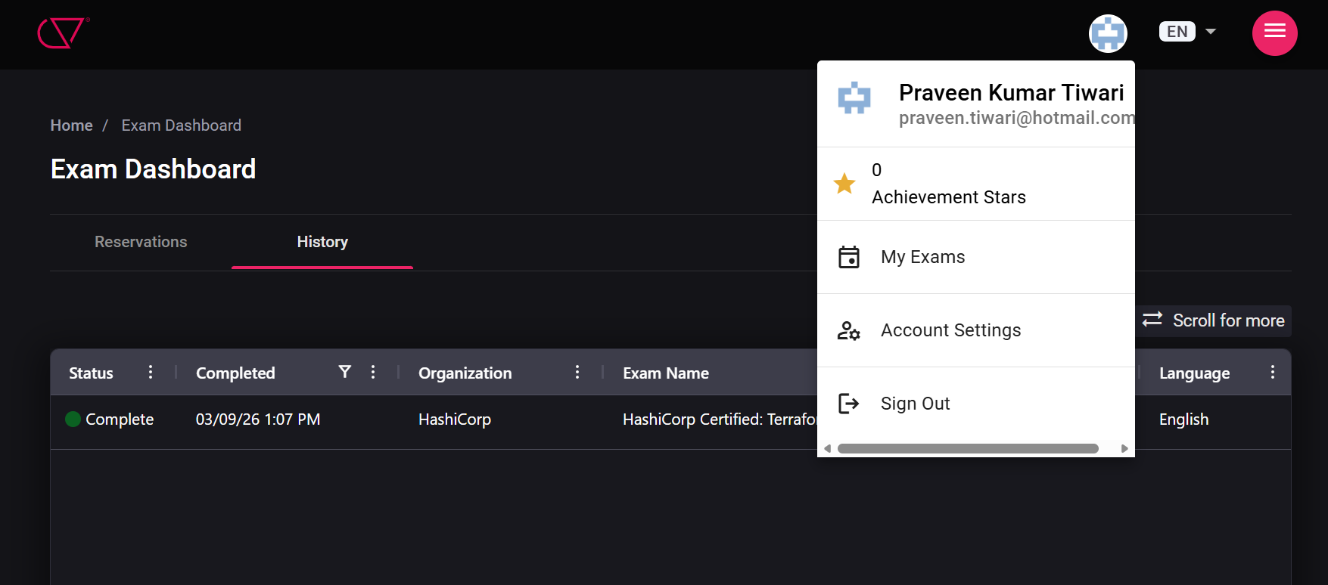

Your organization wants to ensure that third-party security scanning tools can review Terraform plans before any infrastructure changes are applied. Which HCP Terraform feature allows you to integrate external tools into the workflow between the plan and apply phases?
Run tasks in HCP Terraform allows you to integrate external tools and services into your Terraform workflow. They execute between the plan and apply phases, enabling you to call external APIs for tasks like security scanning, cost estimation, or custom validation. Run tasks can be configured as advisory (warnings only) or mandatory (blocking apply if they fail), giving you flexible control over external validations. This differs from run triggers, which automatically start runs in other workspaces, and health checks, which monitor drift and resource health over time.
A root module includes several variables in terraform.tfvars. You add a child module as shown below. What values can the child module access by default?

- module "web" {
- source = "./modules/web"
- }

Ans: By default, child modules in Terraform do not have access to root variables defined in terraform.tfvars. The child module needs to explicitly receive values through the module block to access specific variables from the root module.
Q.. One of your application teams needs to share third-party credentials across multiple workspaces. What is the most appropriate way to configure HCP Terraform and easily meet these requirements? (select three)
Ans:
HCP Terraform variable sets are groups of reusable variables created at the organization level. A variable set can have one of three scopes:
- Global: It will apply to all current and future workspaces within an organization.
- Project-specific: It will apply to all current and future workspaces within the selected projects.
- Workspace-specific: It will apply only to the selected workspaces.
Using a broader variable set scope enables self-service workflows. For instance, you can create a variable set and apply it to a team-specific project, then grant the team permission to create workspaces within the project. Future workspaces will automatically inherit the variable set without requiring additional work or approval. However, we recommend scoping variable sets that contain credentials as narrowly as possible to avoid granting access to teams or workspaces that do not need them.
Q
You’re moving a project to a remote backend so the state is stored in Amazon S3. How do you correctly configure and initialize the backend?
A
Defining the S3 backend in the terraform block and running terraform init is the correct way to configure and initialize the backend for storing state in Amazon S3. This approach ensures that the state is migrated from the local backend to the remote S3 backend.
Q
Which Terraform command will force a resource to be destroyed and recreated even if there are no configuration changes that would require it?
A
The terraform apply -replace=<address> command manually marks a Terraform-managed resource to be replaced, forcing it to be destroyed and recreated during the apply. Even if there are no configuration changes that would require a change or deletion of this resource, this command will instruct Terraform to replace it. This can come in handy if a resource has become degraded or damaged outside of Terraform.
Q.
What are the three core steps that make up the Terraform workflow? (select three)
A.
The core Terraform workflow has three steps:
- Write - Author infrastructure as code.
- Plan - Preview changes before applying.
- Apply - Provision reproducible infrastructure.
Terraform automatically manages most resource dependencies by analyzing references between resources — for example, when one resource uses an attribute from another (aws_instance.example.id). This creates an implicit dependency, and Terraform builds the resource graph on its own.
The depends_on argument is only needed in special cases where:
- There is no direct reference between resources, but a dependency still exists,
- Or you want to override the default dependency graph for ordering or operational reasons.
So Terraform does not require explicit depends_on to manage dependencies in most cas

Q11: How do you prevent a critical resource (like a production database) from being accidentally destroyed?
Answer: You can declare custom rules inside the resource's structural block using a lifecycle block. By setting the parameter prevent_destroy = true, Terraform will reject any execution plan that calls for the destruction of that specific resource, throwing an immediate configuration error before any action is taken.
Terraform Drawback
Drawback | Impact
State file dependency | Risk & complexity
Learning curve | Slower onboarding
Limited error handling | Troubleshooting difficult
No auto drift detection | Requires manual checks
Provider gaps | Feature delays
No rollback | Manual recovery needed
Large infra performance | Slower execution

Scenario-based answers (very high probability questions)
Copilot said:
Copilot
Here are high-probability Azure Terraform scenario-based interview questions with strong structured answers (Problem → Diagnosis → Fix → Best Practice). These are exactly the kind of real-world cases interviewers ask:

✅ 1. Scenario: Terraform deployment fails with “AuthorizationFailed”
❓ Problem
While applying Terraform, you get:
AuthorizationFailed: The client does not have authorization
✅ Answer
Diagnosis:
- The Service Principal / user does not have required RBAC permissions
- Typically missing role on:
  - Subscription
  - Resource Group
Fix:
Shell
az role assignment create \
--assignee <client-id> \
--role Contributor \
--scope /subscriptions/<subscription-id>
Best Practice:
- Use least privilege roles
- Assign roles at resource group level instead of subscription

✅ 2. Scenario: App cannot connect to Azure SQL via Private Endpoint
❓ Problem
App deployed in VNet cannot reach Azure SQL using private endpoint.
✅ Answer
Diagnosis checklist:
- DNS resolution:
Shell
nslookup <sql>.database.windows.net
👉 Should resolve to private IP
- Check:
- Private DNS zone linked to VNet
- NSG allows port 1433
- Private endpoint status = Approved
Fix:
- Create/link DNS:
Terraform
azurerm_private_dns_zone_virtual_network_link
Best Practice:
- Always deploy Private DNS with Private Endpoint
- Validate using nslookup from source VM

✅ 3. Scenario: Terraform apply fails – “Resource already exists”
❓ Problem
Terraform tries to create a resource that already exists.
✅ Answer
Diagnosis:
- Resource was created manually or by another pipeline
Fix:
Shell
terraform import <resource_type>.<name> <resource_id>
Best Practice:
- Avoid manual changes in managed environments
- Maintain IaC consistency

✅ 4. Scenario: Storage Account creation fails
❓ Problem
Error:
The storage account name is already taken
✅ Answer
Diagnosis:
- Storage account names must be:
  - Globally unique
  - Lowercase
  - 3–24 characters
Fix:
Terraform
resource "random_string" "name" {
length = 5
special = false
}

name = "st${random_string.name.result}"
Best Practice:
- Always ensure unique naming using random/variables

✅ 5. Scenario: Terraform stuck during apply (AKS/VM provisioning)
❓ Problem
Terraform runs forever or takes too long.
✅ Answer
Diagnosis:
- Long-running Azure operations (AKS, VM scale sets)
- API throttling or delays
Fix:
- Enable debug:
Shell
TF_LOG=DEBUG terraform apply
- Wait or retry
Best Practice:
- Use appropriate timeouts:
Terraform
timeouts {
create = "60m"
}

✅ 6. Scenario: Private Endpoint created but app still connects to public endpoint
❓ Problem
Traffic is still going via public internet.
✅ Answer
Diagnosis:
- DNS not resolving to private IP
Fix:
- Check:
Shell
nslookup <service>
- Ensure:
  - Private DNS zone exists
  - Linked to VNet
Best Practice:
- Enforce:
Terraform
public_network_access_enabled = false

✅ 7. Scenario: Backend (Azure Storage) not working
❓ Problem
Terraform init fails with storage/backend error.
✅ Answer
Diagnosis:
- Missing permissions on storage account
- Container does not exist
Fix:
- Check role:
  - Storage Blob Data Contributor
- Verify container:
Shell
az storage container list

Best Practice:
- Use separate RG for Terraform state

✅ 8. Scenario: NSG blocking application traffic
❓ Problem
App deployed but not reachable.
✅ Answer
Diagnosis:
- NSG rules deny inbound/outbound traffic
Fix:
- Add rule:
Terraform
security_rule {
name = "AllowHTTP"
priority = 100
direction = "Inbound"
access = "Allow"
protocol = "Tcp"
destination_port_range = "80"
}
Best Practice:
- Always validate using:
Shell
az network watcher test-connectivity

✅ 9. Scenario: Terraform plan shows unexpected changes every time
❓ Problem
No code changes but plan shows updates.
✅ Answer
Diagnosis:
- Auto-generated or dynamic values changing
- Tags modified outside Terraform
Fix:
Terraform
lifecycle {
ignore_changes = [tags]
}
Best Practice:
- Avoid manual changes in Azure portal

✅ 10. Scenario: AKS deployment fails
❓ Problem
AKS cluster creation fails with error.
✅ Answer
Diagnosis:
- Insufficient permissions
- Invalid subnet configuration
- Quota exceeded
Fix:
- Check:
Shell
az vm list-usage --location "East US"
Best Practice:
- Pre-check:
  - Quotas
  - Subnet size
  - Role assignments

✅ 11. Scenario: Cannot destroy resources
❓ Problem
Terraform destroy fails.
✅ Answer
Diagnosis:
- Dependencies exist (NIC, disks, NSG attached)
Fix:
- Manually remove dependencies
- Or:
Shell
terraform state rm <resource>
Best Practice:
- Use proper dependency management

✅ 12. Scenario: App Gateway not routing traffic
❓ Problem
App Gateway created but traffic not reaching backend.
✅ Answer
Diagnosis:
- Backend pool misconfigured
- Health probe failing
Fix:
- Check:
  - Backend IPs
  - HTTP settings
  - Probe status
Best Practice:
- Always configure:
  - Health probes
  - Correct ports

✅ 13. Scenario: DNS not resolving in Azure VNet
❓ Problem
VM inside VNet cannot resolve service name.
✅ Answer
Diagnosis:
- DNS not configured properly
Fix:
- Ensure:
  - Private DNS zone linked
  - Custom DNS configured (if required)
Best Practice:
- Use Azure DNS or centralized DNS solution

✅ 14. Scenario: Multi-environment deployment confusion
❓ Problem
Dev and Prod resources overlap.
✅ Answer
Fix:
- Use:
Shell
terraform workspace new dev
or
Shell
terraform apply -var-file=dev.tfvars
Best Practice:
- Separate:
  - state files
  - resource naming

✅ 15. Scenario: Terraform state mismatch
❓ Problem
State does not match real infra.
✅ Answer
Fix:
Shell
terraform refresh
terraform plan
Best Practice:
- Never manually change production infra

✅ Interview Tip (Very Important)
Always answer like:
✅ Structure:
1. Identify root cause
2. Validate (logs / nslookup / CLI)
3. Fix (code/change)
4. Prevent (best practice)
Scenario-based answers (very high probability questions)
Copilot said:
Copilot
Here are high-probability Azure Terraform scenario-based interview questions with strong structured answers (Problem → Diagnosis → Fix → Best Practice). These are exactly the kind of real-world cases interviewers ask:

✅ 1. Scenario: Terraform deployment fails with “AuthorizationFailed”
❓ Problem
While applying Terraform, you get:
AuthorizationFailed: The client does not have authorization
✅ Answer
Diagnosis:
- The Service Principal / user does not have required RBAC permissions
- Typically missing role on:
  - Subscription
  - Resource Group
Fix:
Shell
az role assignment create \
--assignee <client-id> \
--role Contributor \
--scope /subscriptions/<subscription-id>
Best Practice:
- Use least privilege roles
- Assign roles at resource group level instead of subscription

✅ 2. Scenario: App cannot connect to Azure SQL via Private Endpoint
❓ Problem
App deployed in VNet cannot reach Azure SQL using private endpoint.
✅ Answer
Diagnosis checklist:
- DNS resolution:
Shell
nslookup <sql>.database.windows.net
👉 Should resolve to private IP
- Check:
- Private DNS zone linked to VNet
- NSG allows port 1433
- Private endpoint status = Approved
Fix:
- Create/link DNS:
Terraform
azurerm_private_dns_zone_virtual_network_link
Best Practice:
- Always deploy Private DNS with Private Endpoint
- Validate using nslookup from source VM

✅ 3. Scenario: Terraform apply fails – “Resource already exists”
❓ Problem
Terraform tries to create a resource that already exists.
✅ Answer
Diagnosis:
- Resource was created manually or by another pipeline
Fix:
Shell
terraform import <resource_type>.<name> <resource_id>
Best Practice:
- Avoid manual changes in managed environments
- Maintain IaC consistency

✅ 4. Scenario: Storage Account creation fails
❓ Problem
Error:
The storage account name is already taken
✅ Answer
Diagnosis:
- Storage account names must be:
  - Globally unique
  - Lowercase
  - 3–24 characters
Fix:
Terraform
resource "random_string" "name" {
length = 5
special = false
}

name = "st${random_string.name.result}"
Best Practice:
- Always ensure unique naming using random/variables

✅ 5. Scenario: Terraform stuck during apply (AKS/VM provisioning)
❓ Problem
Terraform runs forever or takes too long.
✅ Answer
Diagnosis:
- Long-running Azure operations (AKS, VM scale sets)
- API throttling or delays
Fix:
- Enable debug:
Shell
TF_LOG=DEBUG terraform apply
- Wait or retry
Best Practice:
- Use appropriate timeouts:
Terraform
timeouts {
create = "60m"
}

✅ 6. Scenario: Private Endpoint created but app still connects to public endpoint
❓ Problem
Traffic is still going via public internet.
✅ Answer
Diagnosis:
- DNS not resolving to private IP
Fix:
- Check:
Shell
nslookup <service>
- Ensure:
  - Private DNS zone exists
  - Linked to VNet
Best Practice:
- Enforce:
Terraform
public_network_access_enabled = false

✅ 7. Scenario: Backend (Azure Storage) not working
❓ Problem
Terraform init fails with storage/backend error.
✅ Answer
Diagnosis:
- Missing permissions on storage account
- Container does not exist
Fix:
- Check role:
  - Storage Blob Data Contributor
- Verify container:
Shell
az storage container list
Best Practice:
- Use separate RG for Terraform state

✅ 8. Scenario: NSG blocking application traffic
❓ Problem
App deployed but not reachable.
✅ Answer
Diagnosis:
- NSG rules deny inbound/outbound traffic
Fix:
- Add rule:
Terraform
security_rule {
name = "AllowHTTP"
priority = 100
direction = "Inbound"
access = "Allow"
protocol = "Tcp"
destination_port_range = "80"
}
Best Practice:
- Always validate using:
Shell
az network watcher test-connectivity

✅ 9. Scenario: Terraform plan shows unexpected changes every time
❓ Problem
No code changes but plan shows updates.
✅ Answer
Diagnosis:
- Auto-generated or dynamic values changing
- Tags modified outside Terraform
Fix:
Terraform
lifecycle {
ignore_changes = [tags]
}
Best Practice:
- Avoid manual changes in Azure portal

✅ 10. Scenario: AKS deployment fails
❓ Problem
AKS cluster creation fails with error.
✅ Answer
Diagnosis:
- Insufficient permissions
- Invalid subnet configuration
- Quota exceeded
Fix:
- Check:
Shell
az vm list-usage --location "East US"
Best Practice:
- Pre-check:
  - Quotas
  - Subnet size
  - Role assignments

✅ 11. Scenario: Cannot destroy resources
❓ Problem
Terraform destroy fails.
✅ Answer
Diagnosis:
- Dependencies exist (NIC, disks, NSG attached)
Fix:
- Manually remove dependencies
- Or:
Shell
terraform state rm <resource>
Best Practice:
- Use proper dependency management

✅ 12. Scenario: App Gateway not routing traffic
❓ Problem
App Gateway created but traffic not reaching backend.
✅ Answer
Diagnosis:
- Backend pool misconfigured
- Health probe failing
Fix:
- Check:
  - Backend IPs
  - HTTP settings
  - Probe status
Best Practice:
- Always configure:
  - Health probes
  - Correct ports

✅ 13. Scenario: DNS not resolving in Azure VNet
❓ Problem
VM inside VNet cannot resolve service name.
✅ Answer
Diagnosis:
- DNS not configured properly
Fix:
- Ensure:
  - Private DNS zone linked
  - Custom DNS configured (if required)
Best Practice:
- Use Azure DNS or centralized DNS solution

✅ 14. Scenario: Multi-environment deployment confusion
❓ Problem
Dev and Prod resources overlap.
✅ Answer
Fix:
- Use:
Shell
terraform workspace new dev
or
Shell
terraform apply -var-file=dev.tfvars
Best Practice:
- Separate:
  - state files
  - resource naming

✅ 15. Scenario: Terraform state mismatch
❓ Problem
State does not match real infra.
✅ Answer
Fix:
Shell
terraform refresh
terraform plan
Best Practice:
- Never manually change production infra

✅ Interview Tip (Very Important)
Always answer like:
✅ Structure:
1. Identify root cause
2. Validate (logs / nslookup / CLI)
3. Fix (code/change)
4. Prevent (best practice)

✅ If you want next level:
I can provide:
- 🔥 Top 20 tricky Azure Terraform questions with answers
- 🔥 Hands-on coding scenarios
- 🔥 AWS vs Azure Terraform comparison (very commonly asked)
You said:
Top 20 tricky Azure Terraform questions with answers
Copilot said:
Copilot
Here are Top 20 tricky Azure Terraform interview questions (with strong, practical answers). These are high-level + real-world + scenario-driven—exactly what interviewers use for mid/senior roles.

✅ Top 20 Tricky Azure Terraform Questions & Answers

🔥 1. How do you handle circular dependencies in Terraform?
✅ Answer:
- Terraform dependency graph fails when resources depend on each other.
- Fix:
  - Remove bidirectional references
  - Use data sources instead of resources
👉 Example:
Terraform
data "azurerm_subnet" "existing" { ... }
✅ Best Practice: Avoid tight coupling between modules/resources.

🔥 2. How do you securely store secrets in Terraform (Azure)?
✅ Answer:
- Never hardcode secrets
- Use:
  - Azure Key Vault
  - Environment variables
  - Terraform variables (sensitive=true)
👉 Example:
Terraform
variable "password" {
sensitive = true
}
✅ Best Practice: Integrate with Key Vault + Managed Identity

🔥 3. How do you handle multiple subscriptions in Terraform?
✅ Answer: Use multiple providers with alias:
Terraform
provider "azurerm" {
alias = "prod"
subscription_id = "xxx"
features {}
}
✅ Use:
Terraform
provider = azurerm.prod

🔥 4. How do you avoid accidental resource deletion?
✅ Answer:
Terraform
lifecycle {
prevent_destroy = true
}
✅ Best Practice: Use for:
- Databases
- Storage accounts

🔥 5. Why is your private endpoint created but not working?
✅ Answer: Most common issue: DNS misconfiguration
✔ Check:
- Private DNS zone linked to VNet
- NSG rules
- Endpoint approval status
✅ Key point: 90% issues = DNS

🔥 6. Difference between Data source vs Resource?
✅ Answer:
Resource | Data Source
Creates infra | Reads existing infra
👉 Example:
Terraform
data "azurerm_resource_group" "rg" {}

🔥 7. Terraform shows changes even when nothing changed—why?
✅ Answer:
- Azure auto-updates:
  - Tags
  - timestamps
- Fix:
Terraform
lifecycle {
ignore_changes = [tags]
}

🔥 8. How do you debug Terraform issues deeply?
✅ Answer:
Shell
TF_LOG=DEBUG terraform apply
✔ Check:
- Azure API responses
- Timeout issues

🔥 9. Why does Terraform fail for Storage Account creation sometimes?
✅ Answer:
- Name must be:
  - globally unique
  - lowercase
✅ Fix: Use random naming:
Terraform
resource "random_string" "suffix" {}

🔥 10. How do you manage Terraform state securely in Azure?
✅ Answer:
- Use:
  - Azure Storage Account
  - Blob container
  - Enable locking
✅ Secure with:
- RBAC
- Private endpoint for storage

🔥 11. How do you deal with Terraform state drift?
✅ Answer:
Shell
terraform plan
terraform apply
Or:
Shell
terraform refresh
✅ Best Practice: Avoid manual changes in Azure Portal

🔥 12. Why is your app still going to public endpoint instead of private?
✅ Answer:
- DNS not resolving to private IP
👉 Check:
Shell
nslookup <service>
✅ Fix:
- Configure Private DNS zone

🔥 13. What if Terraform apply partially fails?
✅ Answer:
- Terraform keeps partial state
✔ Fix:
- Run:
Shell
terraform apply
- Or taint resource:
Shell
terraform taint <resource>

🔥 14. Difference between NSG and Azure Firewall in Terraform?
✅ Answer:
- NSG:
  - Subnet/VM level filtering
- Azure Firewall:
  - Central Layer 7 security
✅ Best Practice:
- Use both in enterprise architecture

🔥 15. How do you deploy resources in different regions?
✅ Answer: Use variables:
Terraform
location = var.region
Or multiple providers

🔥 16. Why does Terraform destroy fail in Azure?
✅ Answer:
- Dependencies exist:
  - NIC attached
  - Disk in use
✅ Fix:
- Remove dependencies first
- Or:
Shell
terraform state rm <resource>

🔥 17. How do you handle large Terraform projects?
✅ Answer:
- Use:
  - Modules
  - Separate state files
  - Layered architecture
✅ Example:
- VNet module
- AKS module
- Monitoring module

🔥 18. What is the difference between count vs for_each? (Tricky)
✅ Answer:
- count → index-based
- for_each → key-based (preferred)
👉 Example:
Terraform
for_each = toset(["dev", "prod"])
✅ Best Practice: Use for_each for stability

🔥 19. How do you handle API throttling in Azure Terraform?
✅ Answer:
- Terraform retries automatically
- Add timeouts:
Terraform
timeouts {
create = "60m"
}
✅ Best Practice:-
- Avoid parallel heavy deployments

🔥 20. Real tricky scenario: Why does private endpoint work from one subnet but not another?
✅ Answer: Possible causes:
- DNS not linked to that subnet’s VNet
- NSG blocking traffic
- Route table misconfiguration
✅ Debug:
- nslookup
- connectivity test:
Shell
az network watcher test-connectivity

✅ Bonus: Interview Winning Tip
When answering tricky questions:
👉 Always follow this flow:
1. Root cause
2. How to verify
3. Fix
4. Best practice
Here are hands-on, practical Terraform coding questions for Azure (exactly what you get in interviews). Each includes problem statement + sample solution + explanation so you can practice confidently.

✅ 1. Create Resource Group + VNet + Subnet
❓ Task
Write Terraform to create:
- Resource Group
- Virtual Network (10.0.0.0/16)
- Subnet (10.0.1.0/24)
✅ Solution
Terraform
provider "azurerm" {
features {}
}

resource "azurerm_resource_group" "rg" {
name = "rg-demo"
location = "East US"
}

resource "azurerm_virtual_network" "vnet" {
name = "vnet-demo"
location = azurerm_resource_group.rg.location
resource_group_name = azurerm_resource_group.rg.name
address_space = ["10.0.0.0/16"]
}

resource "azurerm_subnet" "subnet" {
name = "subnet-demo"
resource_group_name = azurerm_resource_group.rg.name
virtual_network_name = azurerm_virtual_network.vnet.name
address_prefixes = ["10.0.1.0/24"]
}
Show more lines

✅ 2. Deploy VM with NSG (Allow SSH)
❓ Task
Create:
- Linux VM
- NSG allowing port 22
✅ Solution
Terraform
resource "azurerm_network_security_group" "nsg" {
name = "nsg-demo"
location = azurerm_resource_group.rg.location
resource_group_name = azurerm_resource_group.rg.name

security_rule {
name = "AllowSSH"
priority = 1000
direction = "Inbound"
access = "Allow"
protocol = "Tcp"
destination_port_range = "22"
source_port_range = "*"
source_address_prefix = "*"
destination_address_prefix = "*"
}
}
``
Show more lines
👉 You can extend with VM + NIC + Public IP if asked.

✅ 3. Create Storage Account with Unique Name
❓ Task
Ensure globally unique storage account name.
✅ Solution
Terraform
resource "random_string" "suffix" {
length = 5
special = false
}

resource "azurerm_storage_account" "sa" {
name = "st${random_string.suffix.result}"
resource_group_name = azurerm_resource_group.rg.name
location = azurerm_resource_group.rg.location
account_tier = "Standard"
account_replication_type = "LRS"
}
``
Show more lines

✅ 4. Create Private Endpoint for Azure SQL
❓ Task
Create private endpoint to SQL server.
✅ Solution
Terraform
resource "azurerm_private_endpoint" "pe" {
name = "pe-sql"
location = azurerm_resource_group.rg.location
resource_group_name = azurerm_resource_group.rg.name
subnet_id = azurerm_subnet.subnet.id

private_service_connection {
name = "psc-sql"
private_connection_resource_id = azurerm_sql_server.sql.id
subresource_names = ["sqlServer"]
is_manual_connection = false
}
}
Show more lines

✅ 5. Add Private DNS Zone & Link
❓ Task
Ensure private endpoint resolves internally.
✅ Solution
Terraform
resource "azurerm_private_dns_zone" "dns" {
name = "privatelink.database.windows.net"
resource_group_name = azurerm_resource_group.rg.name
}

resource "azurerm_private_dns_zone_virtual_network_link" "link" {
name = "dnslink"
resource_group_name = azurerm_resource_group.rg.name
private_dns_zone_name = azurerm_private_dns_zone.dns.name
virtual_network_id = azurerm_virtual_network.vnet.id
}
Show more lines

✅ 6. Use Module for Reusable VNet
❓ Task
Create reusable module for VNet.
✅ Solution
modules/vnet/main.tf
Terraform
resource "azurerm_virtual_network" "vnet" {
name = var.name
location = var.location
resource_group_name = var.rg
address_space = var.address_space
}
Show more lines
root main.tf
Terraform
module "vnet" {
source = "./modules/vnet"
name = "vnet-dev"
location = "East US"
rg = "rg-demo"
address_space = ["10.0.0.0/16"]
}
Show more lines

✅ 7. Use for_each to Create Multiple Subnets
❓ Task
Create 2 subnets dynamically.
✅ Solution
Terraform
variable "subnets" {
default = {
subnet1 = "10.0.1.0/24"
subnet2 = "10.0.2.0/24"
}
}

resource "azurerm_subnet" "subnets" {
for_each = var.subnets

name = each.key
resource_group_name = azurerm_resource_group.rg.name
virtual_network_name = azurerm_virtual_network.vnet.name
address_prefixes = [each.value]
}

Show more lines

✅ 8. Create AKS Cluster
❓ Task
Deploy basic AKS cluster.
✅ Solution
Terraform
resource "azurerm_kubernetes_cluster" "aks" {
name = "aks-demo"
location = azurerm_resource_group.rg.location
resource_group_name = azurerm_resource_group.rg.name
dns_prefix = "aksdemo"

default_node_pool {
name = "default"
node_count = 2
vm_size = "Standard_DS2_v2"
}

identity {
type = "SystemAssigned"
}
}
Show more lines

✅ 9. Setup Remote Backend (Azure Storage)
❓ Task
Store Terraform state remotely.
✅ Solution
Terraform
terraform {
backend "azurerm" {
resource_group_name = "rg-tfstate"
storage_account_name = "tfstate123"
container_name = "tfstate"
key = "dev.tfstate"
}
}
Show more lines

✅ 10. Add Lifecycle Rule to Prevent Deletion
❓ Task
Prevent deletion of critical resource.
✅ Solution
Terraform
resource "azurerm_sql_database" "db" {
name = "sqldb"

lifecycle {
prevent_destroy = true
}
}
Show more lines

